**Digital Design Lab**

**ECE 315**

**Lab/Project Final**

**Calculator**

**Group # 6**

**Alex Smith, Guntram Weissenberger, Brandon Rubio, Richard Chin**

**Zeinab Ramezani, TA**

**University of Miami**

**4/18/22**

**Overview**

The purpose of this lab is to combine the adder and multiplier designed in the previous labs to complete a fully functioning calculator. It has the ability to add/subtract and multiply with input values between -15 and 15 and outputs the result, between -225 and 225, on the seven-segment display.

**Equipment**

| **Tool** | **Quantity** |
| --- | --- |
| DE1-SoC board  Quartus Prime (Schematic, Symbol, Pins) | 1  1 |

**Description**

In order to implement a fully functioning calculator as per required by the lab instructions, we would need to modify our previous adder, multiplier, and BCD circuits and combine them into one final circuit which we call the Final Calculator. To create our new adder we modified our previous adder to incorporate 5 bits instead of 4. This was due to the fact that we needed to display numbers from -30 to 30 which require a 6th carry bit when converting to and from 2’s complement. Once this was implemented we used that very same adder to create a 5 bit adder/subtractor that used the same concepts of our previous lab 4, now just using 5 bits instead of 4. Since the transition from 4-bit to 5-bits was similar to what we did before in lab 4, we incorporated the same sign bit circuit from lab 4 into our new adder/subtractor. Once this was complete we hooked it up into our new BCD which will be discussed later on.

Continuing, in order to have the multiplier be able to multiply and display numbers from -225 to 225 we just had to modify our previous multiplier slightly. We used the same circuit as in lab 5b however we included a final sign bit output. This sign bit output is connected to a XOR gate with the sign bits of our two input numbers used as inputs. This will result in a positive sign bit if both numbers are positive or negative while resulting in a negative sign if only one number is negative. Once this was established we connected outputs of our multiplier to our new BCD.

The new BCD used was just an extension of our old BCD. In order to do this we mapped out our previous BCD using the same guide given to us in lab 2. However, in order for the BCD to convert a three digit number (maximum 225) we included two more significant bits in the output. These two bits are J and I2 and they can be seen in the schematic for the new BCD in the “Complete Logic Diagram” section below.

Finally, once the Adder/Subtractor, Multiplier, and BCD have been completed we connect them all together into one circuit. These components will all share the same segment displays so in order to differentiate between multiplication and addition/subtraction we had to incorporate multiplier MUXs. The inputs to these muxs will be the outputs from the displays of the Multiplier and Adder/Subtractor. The select line will be determined by the user who will press a button to select between multiplication and addition/subtraction (addition by default, multiplication when pressed. When doing multiplication another push button will be set for the clock input, which must be cycled through in order for the multiplier to output the correct result). Finally the sign bit will also be connected to its own seven segment display.

**Complete Logic Diagram**

*5-bit Adder*

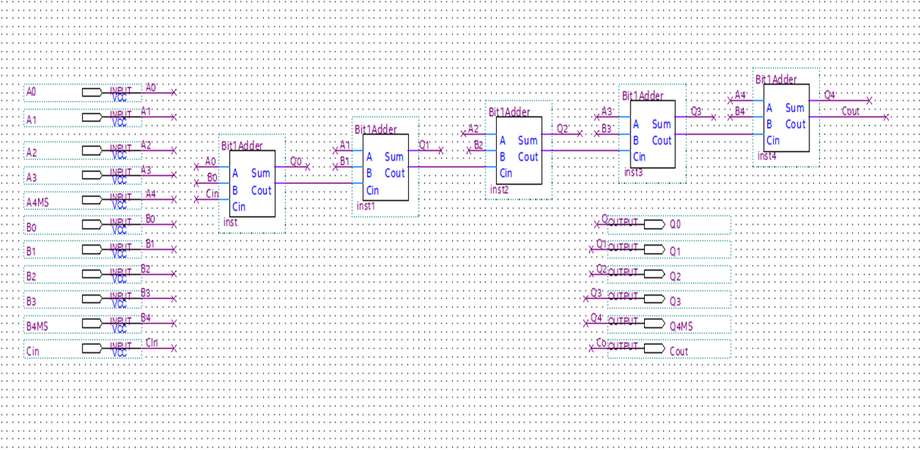

*5-bit Adder/Subtracter*

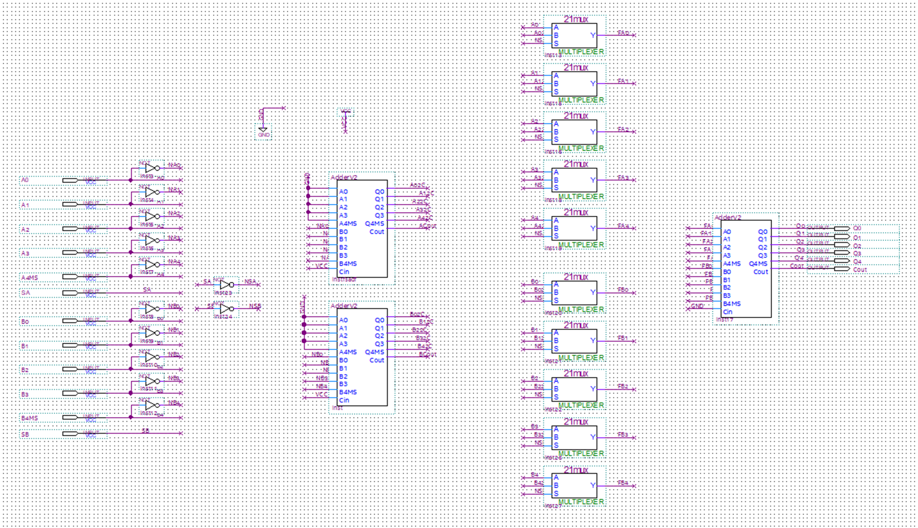

*Final 5-bit Adder/Subtracter*

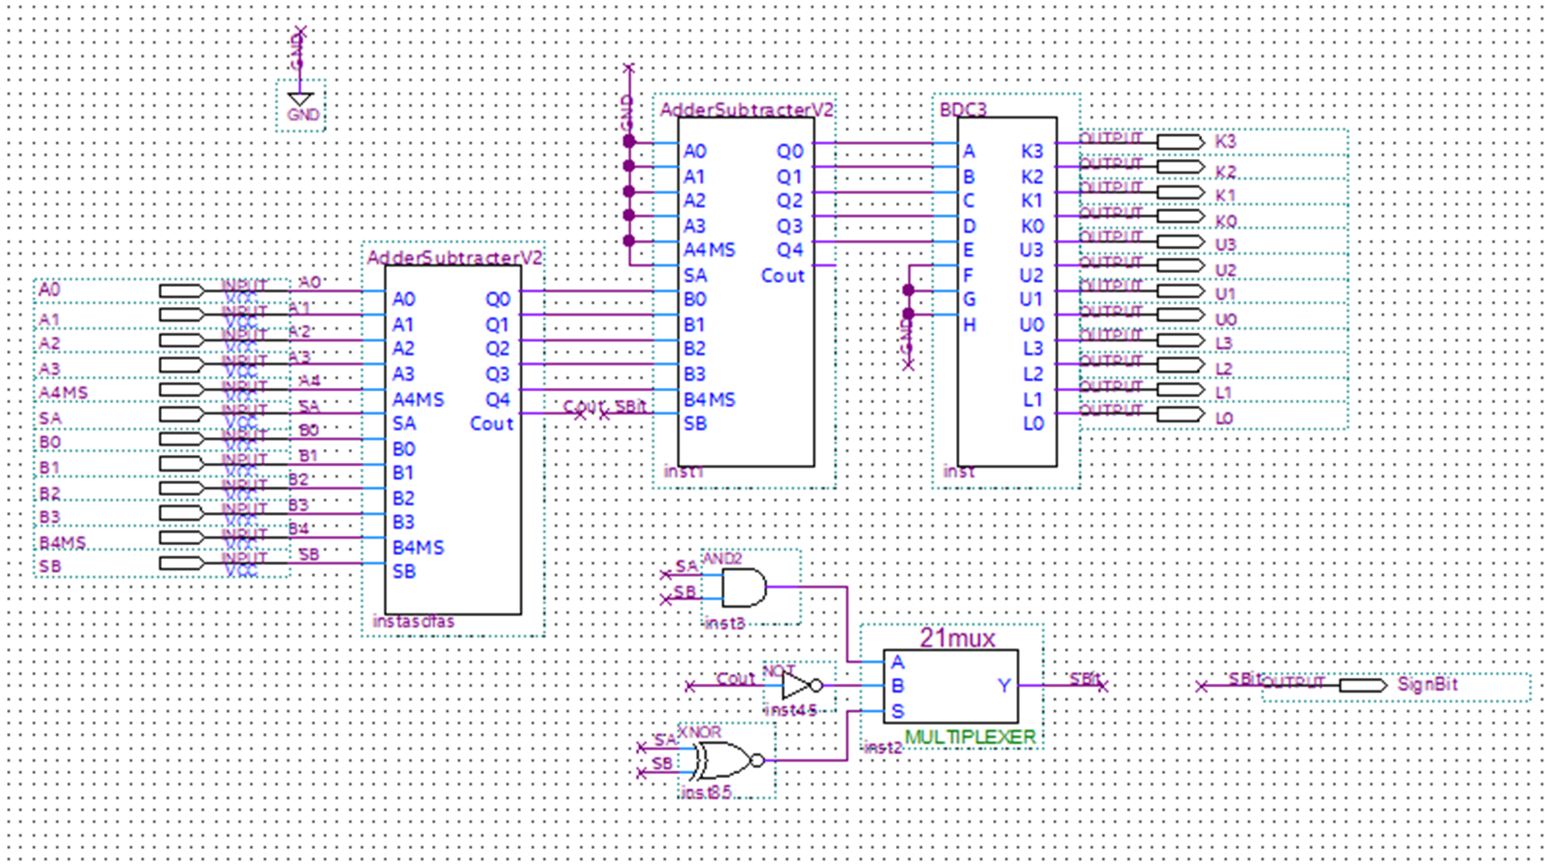

*BCD for 0-225*

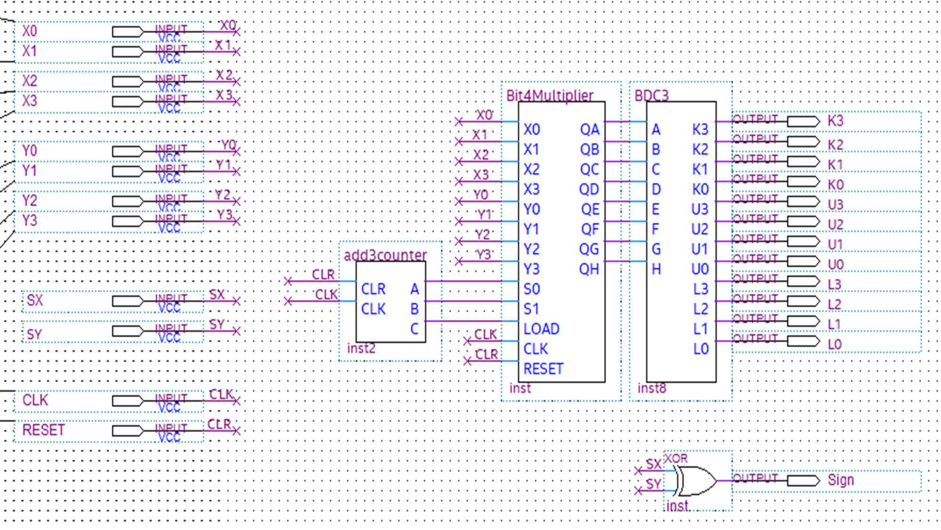

*Final Calculator to Seven Segment Display*

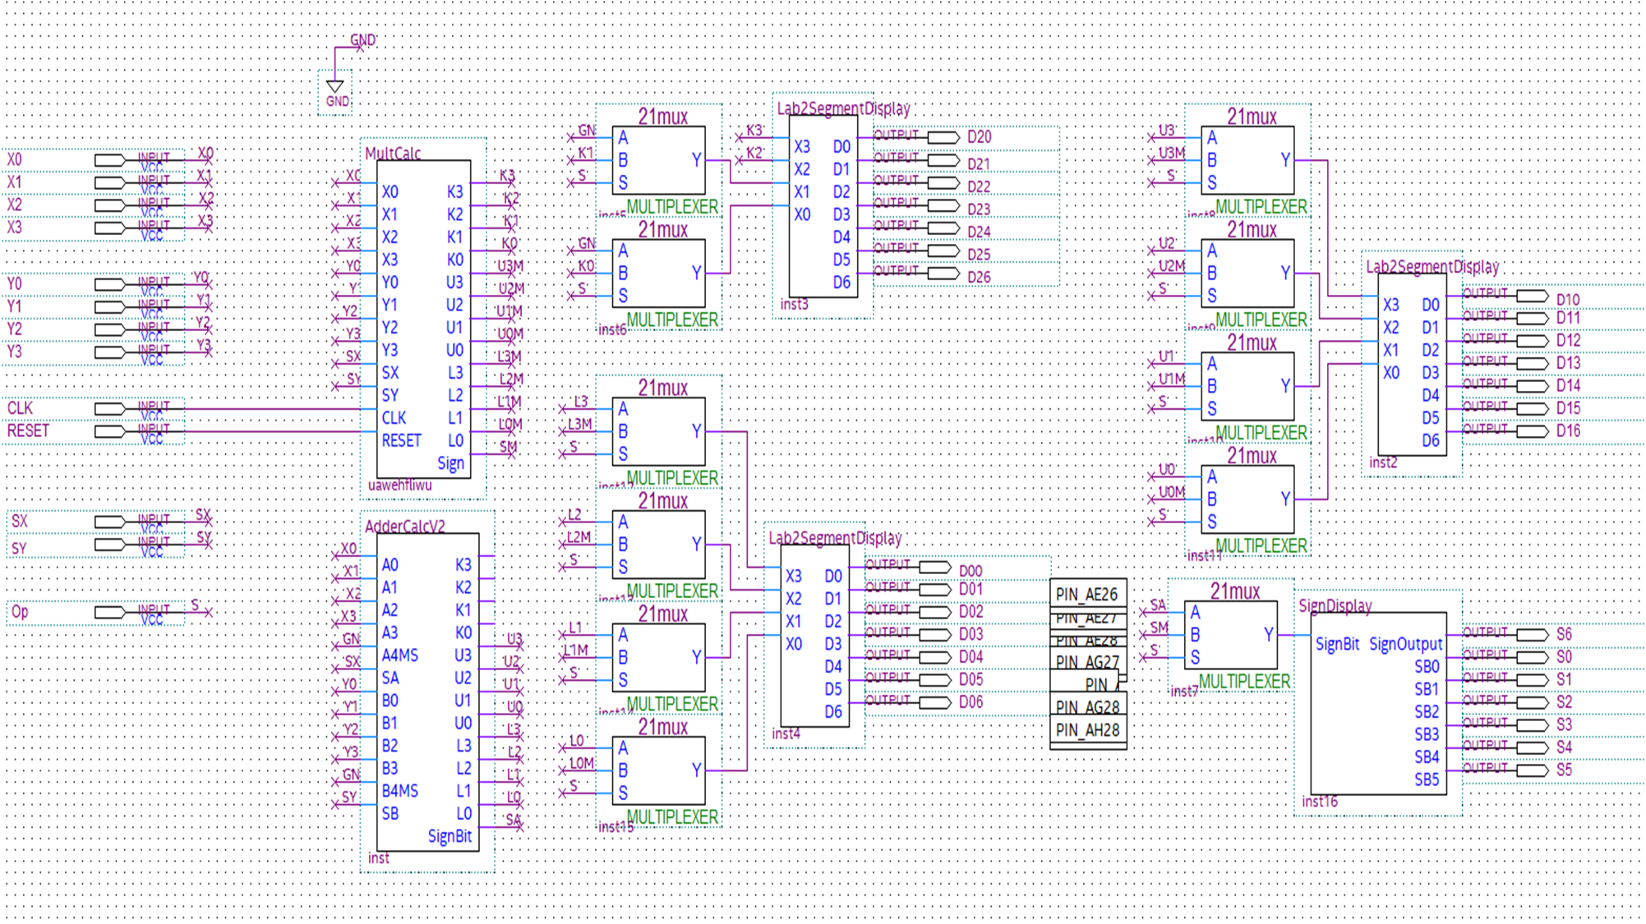

**Conclusion**

In this lab we combined the circuits designed in the last few labs to complete a fully functioning calculator with the capability of adding, subtracting and multiplying. It can take two 4 bit numbers as inputs, and is able to display the inputs and result in decimal, up to 3 digits, on the 7 segment display. It took a long time to put all the designs together yet we were able to get it done rather smoothly and with minimal complications. Despite this some bugs became apparent,. the most notable was a problem with the sign bit in the adder but we were able to fix it. This finalized the calculator and made it fully functional. .